Rafting Site Project

1. Site Logo

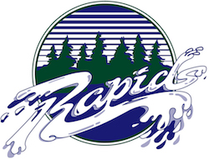

1. Color Labels
   1. primary-color = 272A73
   2. secondary-color = 0B2E1A
   3. accent1-color = 725E54
   4. accent2-color = E4E5E9
2. Font Labels
   1. heading-font = Praise
   2. text-font = Caramel
3. Color Palette

<https://coolors.co/272a73-0b2e1a-725e54-e4e5e9>